PUBLIC NOTICE OF SCHOOL BOARD MEETING

OF MARSHALL PUBLIC SCHOOL DISTRICT

PUBLIC NOTICE is hereby given to the public and news media pursuant to Wisconsin Laws that a SPECIAL MEETING: Committee of the Whole of the School Board of Jt. School District No. 2, Village of Marshall, towns of Cottage Grove, Deerfield, Medina, Sun Prairie, and York, Dane County, Wisconsin will be held on January 9, 2019 commencing at 5:00 PM at the regular meeting place of said School Board in the District Office located in the Marshall Elementary School (617 Madison St.) in the Village of Marshall, Dane County, Wisconsin and that the preliminary agenda for said meeting is as follows:

AGENDA
1. Call meeting to order
- Roll call of the Board
- Approval of agenda
- Proof of giving public notice
- Recognition of visitors
- District Vision and Values
- Consent Agenda
  - Approval of Board minutes dated December 19, 2018
  - Approve Resignations
  - Offer Contracts / Letters of Employment

- Reports
  - Legislation and Advocacy
    - WASB Proposed 2019 Resolutions
      - Resolution 19-11: Oppose/ Eliminate Special Education Vouchers
      - Resolution 19-19: Higher Learning Commission
  - Curriculum and Instruction
    - New course: HS Science
    - HS Course Description Book
  - Negotiations and Policy
    - Update on Support Staff salary and benefits meeting
    - Update on Teacher Compensation Framework Work Group
  - District Safety Team

- Old Business

- New Business
  - Discussion and potential action regarding determining the number of regular education and special education spaces available for full-time Open Enrollment for the 2019-2020 school year.
  - Discussion and review of Community Survey Comment Analysis
  - Review of Referendum Planning Calendar
  - Consideration of referendum question structure and amount

- Contemplated Closed Session

Action to convene into closed session pursuant to section 19.85 of the Wisconsin Statutes

*19.85(1)(c) for the consideration, including deliberation and action, if appropriate, regarding administrative contracts

- Motion to reconvene to open session to take action on the items discussed and
considered in closed session.

13.Adjournment

These are the items known at this time. Adjustments may be made up to 24 hours prior to board meetings. Changes will be posted at each school site, Post Office, F&M Bank, and Marshall Public Library.

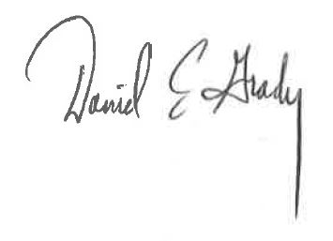
Designee of School Board President

DATED: January 4, 2019

